

# Days of Awe 5784/2023

**September 15-17, and Sept 25-26**

# Congregation Sha’arei Mizrah

**Burquest Jewish Community Centre**

**2860 Dewdney Trunk Road, Coquitlam**

For three decades, the Burquest Jewish Community Association has welcomed Jewish families in Vancouver’s eastern suburbs to High Holiday services on the Days of Awe. This year we are pleased to host **Cantor Frani Goodman** as principal leader of our Rosh Hashanah and Yom Kippur services, supported throughout by David Medzon and other community members. High holiday services fall on the weekend, except for Yom Kippur on a Monday. All events except RH 2 tashlich are at the BJCC.

The service schedule listed below includes: Friday night/Erev Rosh Hashana dinner, an outdoor Tashlich service, shofar blowing on the second day of Rosh Hashana; kiddish lunches, and Yizkor, our remembrance service, on Yom Kippur. Child activities will be available prior to Erev Rosh Hashana, Rosh Hashana 1 and Yom Kippur mornings.

*We will stream services on Zoom and make available our machzor to those who wish to use it at home. A machzor link will be emailed to those on our email list and be posted on* [*www.burquest.org*](http://www.burquest.org)*.*

**Rosh Hashanah**

**Erev Rosh Hashanah: Fri Sept 15**

**4:00-4:30**: **Pre RH-outdoor event for families**: Shofar, Tashlich, Apples & Honey

**6:30 –7:30**: **Kabbalat shabat and Maariv**

Candle lighting, evening service. .

**7:30** K**iddish, Motzi, and Dinner!**

**Rosh Hashanah 1 Sat Sept 16**

**10:00-12:30**: Services

**10:00-12:30**: Children’s activities

…….**12:45:** kiddish lunch

**Rosh Hashanah 2 Sun, Sept 17**

**10:00-12:30**: Services

……**12:45:** Kiddish lunch

**4:00:** Tashlich and Shofar at Lafarge Lake

**Yom Kippur**

**Erev Yom Kippur Kol Nidre: Sun Sept 24**

**6:30**: Music and assembly

**7:00 - 8:00** Candle lighting and Kol Nidre

**Yom Kippur: Mon, Sept 25**

**10:00 - 12:30:** Services

**10:00 - 12:30**: Children’s activities

**1:00** Yizkor remembrance service

childminding available

**1:30 - 5:30**: Service break

**5:30** Healing and meditation circle

**6:00 – 7:00** - Jonah open discussion

**7:00** N’eilah - concluding service

**8:00** Havdalah

… **8:15** Community Potluck Break-Fast

**If you are not a Burquest Jewish Community Association member….**

**Welcome to High Holiday Services**

******************

High Holiday services are organized by Congregation Sha’arei Mizrah,

with support from the Burquest Jewish Community Association membership,

and held at the Burquest Jewish Community Centre, 2860 Dewdney Trunk Road, Coquitlam.

Our services are open to everyone wishing celebrate with us. To continue to operate, we rely on BJCA memberships and additional donations from service attendees, members and non members alike. No other external source of support is used to meet the expenses of Sha’arei Mizrah’s ritual services.

The Burquest Jewish Community Association recently lowered its annual membership fees. If you wish to consider joining, call us at 604-552-7221, visit [www.burquest.org](http://www.burquest.org), or email [admin@burquest.org](mailto:admin@burquest.org).

Non-members are welcome to attend. A donation of $150 would be appropriate and appreciated. Tax-deductible payments may be made by cheque, *Interac*, or credit card. Cheques may be mailed to or dropped off at Burquest. *Interac* e-transfers may be addressed to [admin@burquest.org](mailto:burqpay@telus.net) (no security code necessary). Credit card payments can be made at our website: www.burquest.org under ‘donate’, or information may be provided by phone: 604 552-7221.

**All are welcome to participate regardless of ability to pay.**

Sha’ari Mizrah and the Burquest Jewish Community Association

hope you will join us during this season of reflection and renewal

L’Shana Tovah to all

******************

**Cantor Frani Goodman**

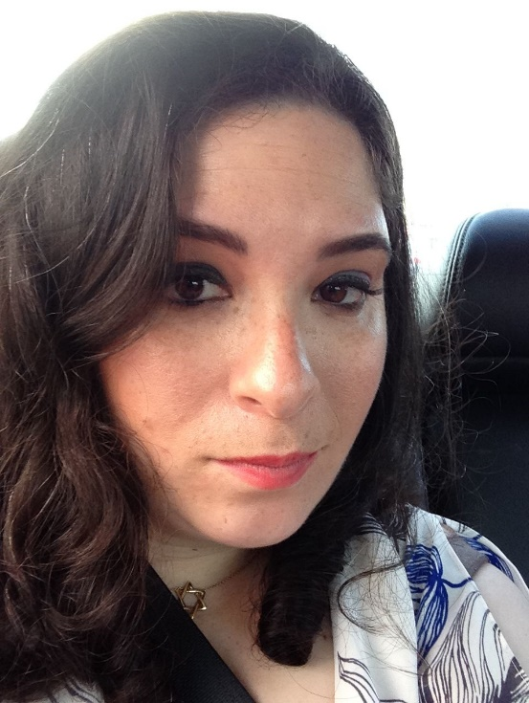  
Cantor Frani Goodman is excited to be joining us on the bimah this High Holiday.  A native Vancouverite, Cantor Goodman graduated from The Jewish Theological Seminary of America in New York in 2014.  Since that time, she has been active in the Jewish community of Greater Vancouver, teaching regular and special programming, at Hebrew Schools all over the lower mainland.  Cantor Frani has been fortunate to give lead services for communities in the US and communities as far away as Gothenburg, Sweden.

Cantor Frani is looking forward to being together, to raise our voices and bring our traditions alive in sacred song for a sweet new year!

*Shanah Tovah u’Metukah!*

*אַחַת שָׁאַלְתִּי מֵאֵת-יְהוָה אוֹתָהּ אֲבַקֵּשׁ:שִׁבְתִּי בְּבֵית-יְהוָה, כָּל-יְמֵי חַיַּי,לַחֲזוֹת בְּנֹעַם-יְהוָה, וּלְבַקֵּר בְּהֵיכָלוֹ.*

*One thing I ask from the Lord, one thing I desire*

*That I might dwell in Your house all the days of my life*

*To behold the graciousness of the Lord, and to enter God's sanctuary​.  
~Psalm 27:4*